White Board

Read the string that contains the “Magic Number”.

Convert the Magic Number to an integer.

Use a loop to write the word “Abracadabra” for as many times as the “Magic Number” and put a number at the front each time to indicate the count in the sequence.

C# Codes

using System;

namespace ConsoleAppStuckInATimeLoop

{

class Program

{

static void Main(string[] args)

{

int length = int.Parse(Console.ReadLine());

//Count starting from 1

int OrderCounter = 1;

while (length >= OrderCounter)

{

Console.WriteLine(OrderCounter.ToString() + " " + "Abracadabra");

OrderCounter++;

}

//Could have used a For loop instead of a while loop

// change i to start at 1 instead of 0

/\*

for (int i = 1; i <= length; i++)

{

Console.WriteLine(i + " " + "Abracadabra");

}

\*/

}

}

}

Kattis ScreenShot

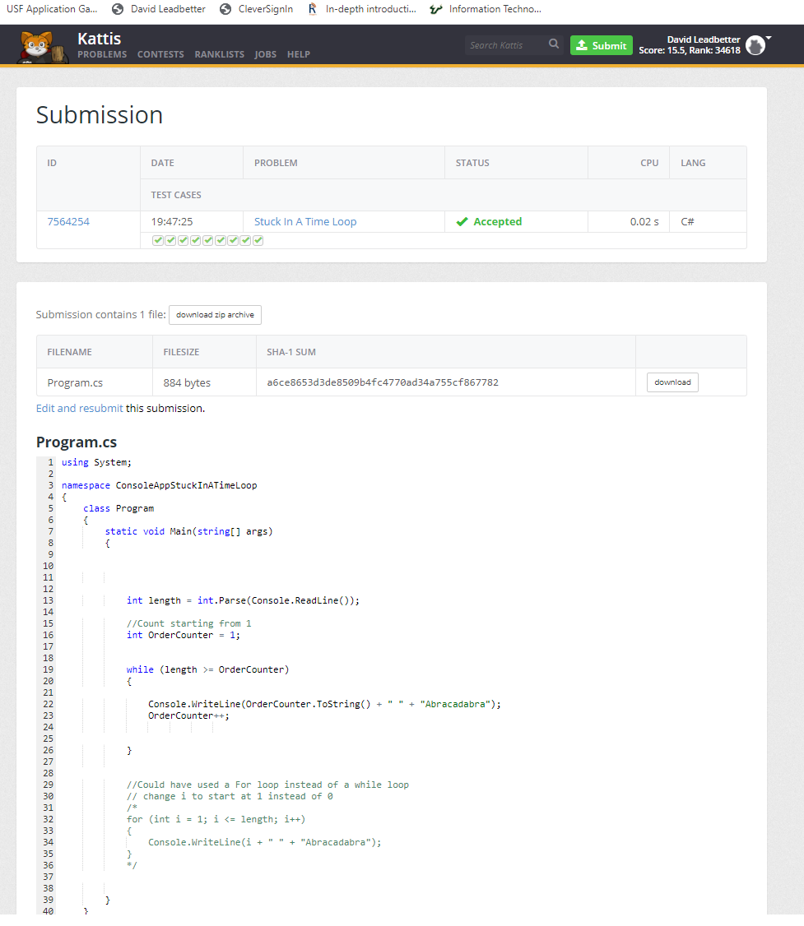

GitHub Link

<https://github.com/dleadbet/ConsoleAppStuckInATimeLoop>